## PROGRAM DEFINITION

|  |
| --- |
|  |
| * A program to print a report for a list of LOIs that need to be followed up on or have succeeded in becoming agreement |

## RELATED TABLES

|  |  |
| --- | --- |
|  | **Access** |
| * - | * - |

## ROLES

|  |  |
| --- | --- |
|  | **Test** |
| * User that has access to program |  |

## INITIAL PROCESS

|  |  |
| --- | --- |
|  | **Test** |
| * Set VAR_COMPANY_ID = Login User’s Company ID * Set VAR_USER_ID = Login User ID * Set VAR_LANGUAGE_ID = Login User’s Language ID * Execute this stored procedure, save the results to VAR_YEAR_RANGE   EXEC RSP_GS_GET_PERIOD_YEAR_RANGE  VAR_COMPANY_ID  , ''  , ''   * Set VAR_LOOKUP_DEPARTMENT_LIST_GET_RECORD = Value from lookup GSL00700 with the following parameters: * VAR_COMPANY_ID * VAR_USER_ID * ‘’ * Set VAR_LOOKUP_SALESMAN_LIST_GET_RECORD = Value from lookup PML00500 with the following parameters: * VAR_COMPANY_ID * selected Property ID * VAR_USER_ID * - |  |

## MAIN FORM

### USER INTERFACE

#### INITIAL VERSION

### BUTTON DEFINITION

|  |  |
| --- | --- |
| **Button Name** | **Action** |
| Print | Run PRINT REPORT PROCESS |

### DISPLAY PROCESS

#### FIELD DEFINITION

|  |  |  |  |
| --- | --- | --- | --- |
| **Name** | **Field** | **Type** | **Validation** |
| Property |  | Combo box  Set VAR_PROPERTY_LIST with  EXEC RSP_GS_GET_PROPERTY_LIST  VAR_COMPANY_ID  , VAR_USER_ID  Set property id = CPROPERTY_ID  Set property name = CPROPERTY_NAME  Set default selected property id = top 1 property id from VAR_PROPERTY_LIST.  Show name from the specific property id | * Mandatory * - |
| Department [From [Code]] |  | Text box | * Mandatory * If user inputs manually, then check its name based on VAR_LOOKUP_DEPARTMENT_LIST_GET_RECORD and save it to VAR_DEPARTMENT_NAME. Finally: * If VAR_DEPARTMENT_NAME is empty, then: * Display message “Department [INPUT Department Code] not found!”, [OK] * Set focus to Department [From [Code]] field * Else, set Department [From [Name]]’s value = VAR_DEPARTMENT_NAME * - |
| Department [From [Lookup]] |  | Lookup | * Enter lookup program GSL00700 with parameters: * VAR_COMPANY_ID * VAR_USER_ID * ‘’   Then save the result to VAR_DEPARTMENT_RESULT   * If VAR_DEPARTMENT_RESULT is empty, then: * Display message “Department [INPUT Department Code] not found!”, [OK] * Set focus to Department [From [Code]] field * Else if VAR_DEPARTMENT_RESULT exists, then: * Set Department [From [Code]] = CDEPT_CODE * Set Department [From [Name]] = CDEPT_NAME * - |
| Department [From [Name]] |  | Text box | * Disabled * - |
| Department [To [Code]] |  | Text box | * Mandatory * If user inputs manually, then check its name based on VAR_LOOKUP_DEPARTMENT_LIST_GET_RECORD and save it to VAR_DEPARTMENT_NAME. Finally: * If VAR_DEPARTMENT_NAME is empty, then: * Display message “Department [INPUT Department Code] not found!”, [OK] * Set focus to Department [To [Code]] field * Else, set Department [To [Name]]’s value = VAR_DEPARTMENT_NAME * - |
| Department [To [Lookup]] |  | Lookup | * Enter lookup program GSL00700 with parameters: * VAR_COMPANY_ID * VAR_USER_ID * ‘’   Then save the result to VAR_DEPARTMENT_RESULT   * If VAR_DEPARTMENT_RESULT is empty, then: * Display message “Department [INPUT Department Code] not found!”, [OK] * Set focus to Department [To [Code]] field * Else if VAR_DEPARTMENT_RESULT exists, then: * Set Department [To [Code]] = CDEPT_CODE * Set Department [To [Name]] = CDEPT_NAME * - |
| Department [To [Name]] |  | Text box | * Disabled * - |
| Salesman [From [Code]] |  | Text box | * Mandatory * If user inputs manually, then check its name based on VAR_LOOKUP_SALESMAN_LIST_GET_RECORD and save it to VAR_SALESMAN_NAME. Finally: * If VAR_SALESMAN_NAME is empty, then: * Display message “Salesman [INPUT Salesman Code] not found!”, [OK] * Set focus to Salesman [From [Code]] field * Else, set Salesman [From [Name]]’s value = VAR_SALESMAN_NAME * - |
| Salesman [From [Lookup]] |  | Lookup | * Enter lookup program PML00500 with parameters: * VAR_COMPANY_ID * Selected Property Id * VAR_USER_ID   Then save the result to VAR_SALESMAN_RESULT   * If VAR_SALESMAN_RESULT is empty, then: * Display message “Salesman [INPUT Salesman Code] not found!”, [OK] * Set focus to Salesman [From [Code]] field * Else if VAR_SALESMAN_RESULT exists, then: * Set Salesman [From [Code]] = CSALESMAN_ID * Set Salesman [From [Name]] = CSALESMAN_NAME * - |
| Salesman [From [Name]] |  | Text box | * Disabled * - |
| Salesman [To [Code]] |  | Text box | * Mandatory * If user inputs manually, then check its name based on VAR_LOOKUP_SALESMAN_LIST_GET_RECORD and save it to VAR_SALESMAN_NAME. Finally: * If VAR_SALESMAN_NAME is empty, then: * Display message “Salesman [INPUT Salesman Code] not found!”, [OK] * Set focus to Salesman [To [Code]] field * Else, set Salesman [To [Name]]’s value = VAR_SALESMAN_NAME * - |
| Salesman [To [Lookup]] |  | Lookup | * Enter lookup program PML00500 with parameters: * VAR_COMPANY_ID * Selected Property Id * VAR_USER_ID   Then save the result to VAR_SALESMAN_RESULT   * If VAR_SALESMAN_RESULT is empty, then: * Display message “Salesman [INPUT Salesman Code] not found!”, [OK] * Set focus to Salesman [To [Code]] field * Else if VAR_SALESMAN_RESULT exists, then: * Set Salesman [To [Code]] = CSALESMAN_ID * Set Salesman [To [Name]] = CSALESMAN_NAME * - |
| Salesman [To [Name]] |  | Text box | * Disabled * - |
| Period [From [Year]] |  | Spinner  Spinner value:   * Minimum = VAR_YEAR_RANGE.IMIN_YEAR * Maximum = VAR_YEAR_RANGE.IMAX_YEAR   Set default spinner value:  SELECT YEAR(dbo.RFN_GET_DB_TODAY (VAR_COMPANY_ID)) | * Mandatory * - |
| Period [From [Month]] |  | Combo box  Set VAR_PERIOD_MONTH_LIST (as array of object) with VAR_MONTH_NUMBER and VAR_MONTH_NAME.  Set VAR_MONTH_NUMBER = 01, 02, … , 12  Set VAR_MONTH_NAME = January, February, … , December  Set default combo box value month name based on  SELECT MONTH(dbo.RFN_GET_DB_TODAY (VAR_COMPANY_ID)) | * Mandatory * - |
| Period [To [Year]] |  | Spinner  Spinner value:   * Minimum = VAR_YEAR_RANGE.IMIN_YEAR * Maximum = VAR_YEAR_RANGE.IMAX_YEAR   Set default spinner value:  SELECT YEAR(dbo.RFN_GET_DB_TODAY (VAR_COMPANY_ID)) | * Mandatory * - |
| Period [To [Month]] |  | Combo box  Set VAR_PERIOD_MONTH_LIST (as array of object) with VAR_MONTH_NUMBER and VAR_MONTH_NAME.  Set VAR_MONTH_NUMBER = 01, 02, … , 12  Set VAR_MONTH_NAME = January, February, … , December  Set default combo box value month name based on  SELECT MONTH(dbo.RFN_GET_DB_TODAY (VAR_COMPANY_ID)) | * Mandatory * - |
| Report Type |  | Radio button  Radio Value   * ‘1’ = Summary * ‘2’ = Detail   Set default value to Summary | * Mandatory * - |
| Filter [Outstanding Agreement Transaction] |  | Check box  Set:   * When True, then 1 * When False, then 0   Set default value to False | * Optional * - |

### PRINT REPORT PROCESS

#### REPORT LAYOUT

PAPER SIZE: A4 LANDSCAPE

FONT SIZE: 7

REPORT TYPE: SUMMARY CR01

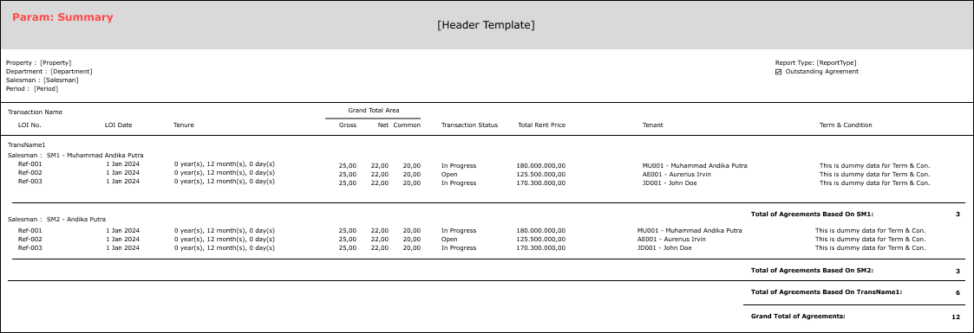

PAPER SIZE: A4 LANDSCAPE

FONT SIZE: 7

REPORT TYPE: DETAIL CR01 CR03 CR04

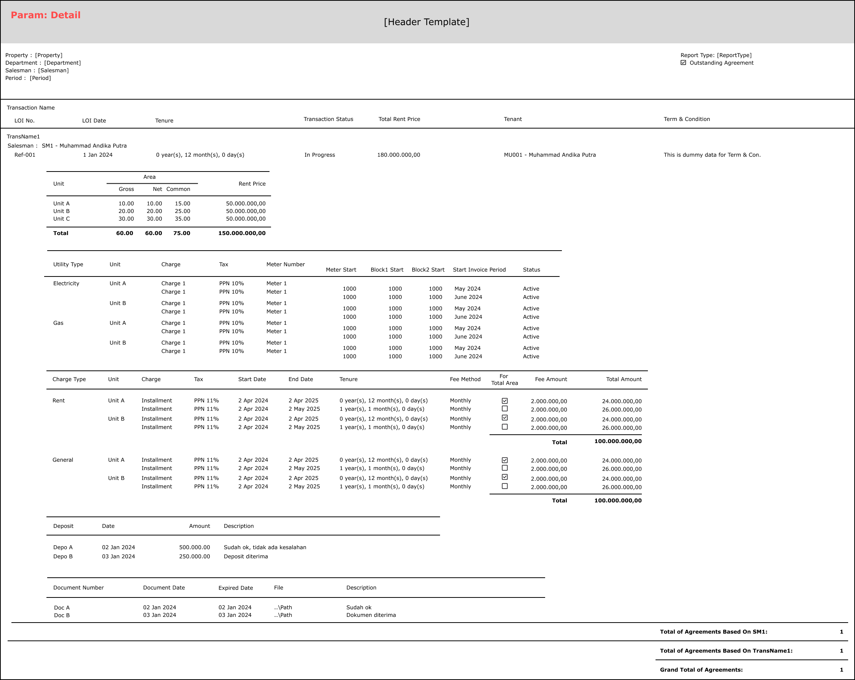

#### REPORT DEFINITION

REPORT SECTION FOR HEADER (IN GENERAL)

|  |  |  |  |
| --- | --- | --- | --- |
| **Section** | **Name** | **Field** | **Validation** |
| HEADER | Property | Selected Property | Show Property ID – Property Name  Ex. “ABCDE – Global Property” |
| Department | Selected Department | IF Department [From [Code]] <> Department [To [Code]], then “Department [From [Name]] (Department [From [Code]]) – Department [To [Name]] (Department [To [Code]])”  ELSE, “Department [From [Name]] (Department [From [Code]])”  Ex. 1  Selected from: MNY – Department Keuangan  Selected to: ITSI – Department Sistem Informasi  Hence, show “Department Keuangan (MNY) – Department Sistem Informasi (ITSI)”  Ex. 2  Selected from: ITSI – Department Sistem Informasi  Selected to: ITSI – Department Sistem Informasi  Hence, show “Department Sistem Informasi (ITSI)” |
| Salesman | Selected Salesman | IF Salesman [From [Code]] <> Salesman [To [Code]], then “Salesman [From [Name]] (Salesman [From [Code]]) – Salesman [To [Name]] (Salesman [To [Code]])”  ELSE, “Salesman [From [Name]] (Salesman [From [Code]])”  Ex. 1  Selected from: MU01 – Andika Putra  Selected to: AE01 – Aurerius Irvin  Hence, show “Andika Putra (MU01) – Aurerius Irvin (AE01)”  Ex. 2  Selected from: MU01 – Andika Putra  Selected to: MU01 – Andika Putra  Hence, show “Andika Putra (MU01)” |
| Period | Selected Period | If Period [From] <> Period [To], then show “MMM yyyy – MMM yyyy”  Ex. Period [From] = “200109” and Period [To] = “200110”, then show “September 2001 – October 2001”  Else, show “MMM yyyy"  Ex. Period [From] = “200109” and Period [From] = “200109”, then show “September 2001” |
| Report Type | Selected Report Type | Show Report Type’s value  Ex. “Summary” |
| Outstanding Agreement Transaction | Selected Filter [Outstanding Agreement Transaction] | If Filter [Outstanding Agreement Transaction] = True, then show check box with checked value  Else, show check box with unchecked value |

REPORT SECTION FOR SUMMARY

|  |  |  |  |
| --- | --- | --- | --- |
| **Section** | **Name** | **Field** | **Validation** |
| REPORT GROUP | Transaction | CTRANS_CODE |  |
| Salesman | CSALESMAN_ID |  |
| GROUP BY TRANSACTION [HEADER] | Transaction Name | CTRANS_NAME |  |
| GROUP BY SALESMAN [HEADER] | Salesman | CSALESMAN_ID - CSALESMAN_NAME |  |
| DETAIL | LOI No. | CREF_NO |  |
| LOI Date | CREF_DATE |  |
| Tenure | CTENURE |  |
| Grand Total Area (Gross) | NTOTAL_GROSS_AREA_SIZE |  |
| Grand Total Area (Net) | NTOTAL_NET_AREA_SIZE |  |
| Grand Total Area (Common) | NTOTAL_COMMON_AREA_SIZE |  |
| Transaction Status | CTRANS_STATUS_NAME |  |
| Total Rent Price | NTOTAL_PRICE |  |
| ~~Tax~~ | ~~CTAX CR01~~ |  |
| Tenant | CTENANT_ID - CTENANT_NAME |  |
| Term & Condition | CTC_MESSAGE |  |
| GROUP BY SALESMAN [FOOTER] | Sub Total of Agreement | - | Count of CREF_NO |
| GROUP BY TRANSACTION [FOOTER] | Sub Total of Agreement | - | Count of CREF_NO |
| SUMMARY | Grand Total of Agreement | - | Count of CREF_NO |

REPORT SECTION FOR DETAIL

|  |  |  |  |
| --- | --- | --- | --- |
| **Section** | **Name** | **Field** | **Validation** |
| REPORT GROUP | Transaction | CTRANS_CODE |  |
| Salesman | CSALESMAN_ID |  |
| LOI No. | CREF_NO |  |
| GROUP BY TRANSACTION [HEADER] | Transaction Name | CTRANS_NAME |  |
| GROUP BY SALESMAN [HEADER] | Salesman | CSALESMAN_ID - CSALESMAN_NAME |  |
| GROUP BY LOI NO. [HEADER] | LOI No. | CREF_NO |  |
| LOI Date | CREF_DATE |  |
| Tenure | CTENURE |  |
| Transaction Status | CTRANS_STATUS_NAME |  |
| Total Rent Price | NTOTAL_PRICE |  |
| ~~Tax~~ | ~~CTAX CR01~~ |  |
| Tenant | CTENANT_ID - CTENANT_NAME |  |
| Term & Condition | CTC_MESSAGE |  |
| DATA UNIT [HEADER] | - | - | If (CUNIT_DETAIL_ID is null), then suppress the section |
| DATA UNIT [DETAIL] | Unit | CUNIT_DETAIL_ID - CUNIT_DETAIL_NAME | If (CUNIT_DETAIL_ID is null), then suppress the section  For this Section, use a Data Transfer Object, named VAR_DTO_UNIT with the following groups:   * CTRANS_CODE * CSALESMAN_ID * CREF_NO * CUNIT_DETAIL_ID |
| Gross Area | NUNIT_DETAIL_GROSS_AREA_SIZE |  |
| Net Area | NUNIT_DETAIL_NET_AREA_SIZ |  |
| Common Area | NUNIT_DETAIL_COMMON_AREA_SIZE |  |
| Rent Price | NUNIT_DETAIL_PRICE |  |
| DATA UNIT [FOOTER] | Total of Gross Area | - | If (CUNIT_DETAIL_ID is null), then suppress the section  Use Formula sum of DATA UNIT [DETAIL [NUNIT_DETAIL_GROSS_AREA_SIZE]] |
| Total of Net Area | - | Use Formula sum of DATA UNIT [DETAIL [NUNIT_DETAIL_NET_AREA_SIZE]] |
| Total of Common Area | - | Use Formula sum of DATA UNIT [DETAIL [NUNIT_DETAIL_COMMON_AREA_SIZE]] |
| Total of Price | - | Use Formula sum of DATA UNIT [DETAIL [NUNIT_DETAIL_PRICE]] |
| DATA UTILITY [HEADER] | Utility Type | CUTILITY_DETAIL_TYPE_NAME | If (CUTILITY_DETAIL_TYPE_ID is null), then suppress the section  For this Section, use a Data Transfer Object, named VAR_DTO_UTILITY with the following groups:   * CTRANS_CODE * CSALESMAN_ID * CREF_NO * CUTILITY_DETAIL_TYPE_ID |
| DATA UTILITY [UNIT [HEADER]] | Unit | CUTILITY_DETAIL_UNIT_NAME | If (CUTILITY_DETAIL_TYPE_ID is null), then suppress the section  For this Section, use a Data Transfer Object, named VAR_DTO_UTILITY_UNIT with the following groups:   * CTRANS_CODE * CSALESMAN_ID * CREF_NO * CUTILITY_DETAIL_TYPE_ID * CUTILITY_DETAIL_UNIT_NAME |
| DATA UTILITY [UNIT [DETAIL]] | Charge | CUTILITY_DETAIL_CHARGE_NAME | If (CUTILITY_DETAIL_TYPE_ID is null), then suppress the section |
| Tax | CUTILITY_DETAIL_TAX_NAME |  |
| Meter Number | CUTILITY_DETAIL_METER_NO |  |
| Meter Start | ~~IUTILITY_DETAIL_METER_START~~  NUTILITY_DETAIL_METER_START **CR02** |  |
| Block1 Start | NUTILITY_DETAIL_BLOCK1_START **CR03** |  |
| Block2 Start | NUTILITY_DETAIL_BLOCK2_START **CR03** |  |
| Start Invoice Period | CUTILITY_DETAIL_START_INV_PRD |  |
| ~~Invoicing Period (months)~~  **CR03** | ~~IUTILITY_DETAIL_INVOICING_PERIOD~~ |  |
| Status | CUTILITY_DETAIL_STATUS_NAME |  |
| DATA UTILITY [UNIT [FOOTER]] | - | - | If (CUTILITY_DETAIL_TYPE_ID is null), then suppress the section |
| DATA UTILITY [FOOTER] | - | - | If (CUTILITY_DETAIL_TYPE_ID is null), then suppress the section |
| DATA CHARGE [HEADER] | Charge Type | CCHARGE_DETAIL_TYPE_NAME | If (CCHARGE_DETAIL_TYPE_NAME is null), then suppress the section  For this Section, use a Data Transfer Object, named VAR_DTO_CHARGE with the following groups:   * CTRANS_CODE * CSALESMAN_ID * CREF_NO * CCHARGE_DETAIL_TYPE_NAME |
| DATA CHARGE [UNIT [HEADER]] | Unit | CCHARGE_DETAIL_UNIT_NAME | If (CCHARGE_DETAIL_TYPE_NAME is null), then suppress the section  For this Section, use a Data Transfer Object, named VAR_DTO_CHARGE_UNIT with the following groups:   * CTRANS_CODE * CSALESMAN_ID * CREF_NO * CCHARGE_DETAIL_TYPE_NAME * CCHARGE_DETAIL_UNIT_NAME |
| DATA CHARGE [UNIT [DETAIL]] | Charge | CCHARGE_DETAIL_CHARGE_NAME | If (CCHARGE_DETAIL_TYPE_NAME is null), then suppress the section |
| Tax | CCHARGE_DETAIL_TAX_NAME |  |
| Start Date | CCHARGE_DETAIL_START_DATE |  |
| End Date | CCHARGE_DETAIL_END_DATE |  |
| Tenure | CCHARGE_DETAIL_TENURE |  |
| Fee Method | CCHARGE_DETAIL_FEE_METHOD |  |
| For Total Area | LFOR_TOTAL_AREA **CR04** |  |
| Fee Amount | NCHARGE_DETAIL_FEE_AMOUNT |  |
| Total Amount **CR04** | NCHARGE_DETAIL_CALCULATED_FEE_AMOUNT |  |
| DATA CHARGE [UNIT [FOOTER]] | - | - | If (CCHARGE_DETAIL_TYPE_NAME is null), then suppress the section |
| DATA CHARGE [FOOTER] | Total of Total Amount | - | If (CCHARGE_DETAIL_TYPE_NAME is null), then suppress the section  Use Formula sum of DATA CHARGE [HEADER [NCHARGE_DETAIL_CALCULATED_FEE_AMOUNT]] |
| DATA DEPOSIT [HEADER] | - | - | If (CDEPOSIT_DETAIL_ID is null), then suppress the section  For this Section, use a Data Transfer Object, named VAR_DTO_DEPOSIT with the following groups:   * CTRANS_CODE * CSALESMAN_ID * CREF_NO * CDEPOSIT_DETAIL_ID |
| DATA DEPOSIT [DETAIL] | Deposit | CDEPOSIT_DETAIL_ID | If (CDEPOSIT_DETAIL_ID is null), then suppress the section |
| Date | CDEPOSIT_DETAIL_DATE |  |
| Amount | NDEPOSIT_DETAIL_AMOUNT |  |
| Description | CDEPOSIT_DETAIL_DESCRIPTION |  |
| DATA DEPOSIT [FOOTER] | - | - | If (CDEPOSIT_DETAIL_ID is null), then suppress the section |
| DATA DOCUMENT [HEADER] | - | - | If (CDOCUMENT_DETAIL_NO is null), then suppress the section |
| DATA DOCUMENT [DETAIL] | Document Number | CDOCUMENT_DETAIL_NO | If (CDOCUMENT_DETAIL_NO is null), then suppress the section  For this Section, use a Data Transfer Object, named VAR_DTO_DOCUMENT with the following groups:   * CTRANS_CODE * CSALESMAN_ID * CREF_NO * CDOCUMENT_DETAIL_NO |
| Document Date | CDOCUMENT_DETAIL_DATE |  |
| Expired Date | CDOCUMENT_DETAIL_EXPIRED_DATE |  |
| File | CDOCUMENT_DETAIL_FILE |  |
| Description | CDOCUMENT_DETAIL_DESCRIPTION |  |
| DATA DOCUMENT [FOOTER] | - | - | If (CDOCUMENT_DETAIL_NO is null), then suppress the section |
| GROUP BY LOI NO. [FOOTER] | - | - | If (CDEPOSIT_DETAIL_ID is null), then suppress the section |
| GROUP BY SALESMAN [FOOTER] | Sub Total of Agreement | - | Count of CREF_NO |
| GROUP BY TRANSACTION [FOOTER] | Sub Total of Agreement | - | Count of CREF_NO |
| FOOTER | Grand Total of Agreement | - | Count of CREF_NO |

#### VALIDATION

|  |  |  |
| --- | --- | --- |
| Property | Empty | Please select Property |
| Department | Department [From [Code]] is empty **or** Department [To [Code]] is empty | Please select Department |
| Salesman | Salesman [From [Code]] is empty **or** Salesman [To [Code]] is empty | Please select Salesman |
| Period | Period [From] is higher than Period [To] | Period (From) cannot be higher than Period (To) |

#### ACTION

|  |
| --- |
|  |
| * Execute this stored procedure:   RSP_PMR00220_GET_REPORT  VAR_COMPANY_ID  , selected Property ID  , selected Department [From [Code]]  , selected Department [To [Code]]  , selected Salesman [From [Code]]  , selected Salesman [To [Code]]  , selected Period [From]  , selected Period [To]  , selected Report Type  , selected Filter [Outstanding Agreement Transaction]  , VAR_LANGUAGE_ID  Note for sending those parameters to execute the stored procedure above:   * Selected Period [From]’s value should be “yyyymm” * Selected Period [To]’s value should be “yyyymm” * Selected Report Type’s value should be either ‘1’ or ‘2’ * Selected Filter [Outstanding Agreement Transaction] should be either 1 or 2 * **!IMPORTANT!: DIFFERENT SELECTED REPORT TYPE RESULTING IN DIFFERENT OUTPUT** * Ex. 1 for Summary [THERE IS CURRENTLY NO AVAILABLE DATA // TABLE IS NOT EXISTS]   EXEC RSP_PMR00220_GET_REPORT  'RCD'  , 'ASHMD'  , 'ACC'  , 'ACC'  , 'C098'  , 'TEST01'  , '202401'  , '202412'  , '1'  , 0  , 'EN'   * Ex. 2 for Detail [THERE IS CURRENTLY NO AVAILABLE DATA // TABLE IS NOT EXISTS]   EXEC RSP_PMR00220_GET_REPORT  'RCD'  , 'ASHMD'  , 'ACC'  , 'ACC'  , 'C098'  , 'TEST01'  , '202401'  , '202412'  , '2'  , 0  , 'EN'   * - |

# CR LIST

|  |  |  |
| --- | --- | --- |
| **CR** | **Description** | **Notes** |
| CR01, CH  15 Aug 2024 | * Hapus kolom tax di report * Pindah posisi Informasi salesman |  |
| CR02, CH  01 NOV 2024 | * Ubah kolom Meter dari integer menjadi decimal |  |
| CR03, CH  07 NOV 2024 | * Hilangkan kolom Invoicing Period pada UI Report Detail bagian Utility * Tambahkan kolom block1 start dan block2 start |  |
| CR04, CH  14 MAR 2025 | * Tambah For Total Area, LFOR_TOTAL_AREA * Ganti Nama Kolom Calculated Fee Amount jadi Total Amount |  |

#### TEMPLATE

#### VALIDATION

|  |  |  |
| --- | --- | --- |
| **Field** | **Condition** | **Validation Message** |
|  |  |  |
|  |  |  |

#### ACTION

|  |
| --- |
|  |
|  |